Upper Intermediate Periods 1-3 Vocabulary Set 1 Practice Material
PART 1: Choose the word that matches the given dictionary definition by choosing A, B, C, D or E:
1 earlier in time or order
A recently
B previously
C unfortunately
D properly
E artificially

2 the speed at which someone or something moves
A phase
B duration
C pace
D artefact
E scale

3 ideas, advice, money, or effort that you put into a job or activity to help it succeed
A target
B composition
C range
D input
E relevance

4 someone who has been forced to leave their country, especially during a war, or for political or religious reasons
A immigrant
B sufferer
C protester
D refugee
E pedestrian

5 different from what is normal or expected, especially in a way that you disapprove of or cannot understand
A odd
B embarrassed
C sacred
D tender
E mysterious

PART 2: Fill in the blanks in the text(s) by choosing A, B, C, D or E.
Text 1: A new study has found that the (1)______________ of stricter gun control laws in a number of countries reduced firearm deaths. According to the research, which analyzed data from 194 countries over a period of 15 years, one (2)______________ of strict regulations, was fewer fatalities in countries where such regulations were applied. The findings highlight the (3)______________ effects of having weak gun laws and suggest that countries should (4)______________ on evidence-based policies when dealing with this gun issue.
1 A demonstration B composition C persuasion D interruption E implementation
2 A component B requirement C consequence D suggestion E input
3 A unforgettable B adverse C pure D domestic E relevance
4 A rely B implement C comment D enhance E apply

Text 2: The Simpson family was in a very bad situation and they were ready to change things for the better. In a(n) (5)______________ attempt to save their home, the family sold their car and took on extra jobs. (6)______________ issues, such as disagreements about money among family members, began to arise, and added stress to their already challenging situation. Sometimes, heated arguments would result in (7)______________, with words that are meant to hurt rather than heal. They knew they had to (8)______________ these difficulties together, and find ways to support each other. Despite the hardships, their strong bonds helped them face each challenge. In the end, their (9)______________ paid off, and they managed to keep their home, learning valuable lessons about what it means to be a family.
5 A painful B desperate C miraculous D fair E global
6 A domestic B appealing C inefficient D poisonous E immoral
7 A phases B demonstrations C clarifications D insults E perceptions
8 A overcome B implement C commit D adjust E abandon
9 A comments B states C targets D favors E sacrifices

Text 3: Maintaining a healthy lifestyle involves a(n) (10)______________ to regular exercise and nutritious eating habits. Many people find it challenging to (11)______________ unhealthy practices such as consuming excessive sugary snacks or skipping meals. However, it's essential to (12)______________ your diet with a range of fruits, vegetables, and proteins to ensure proper nutrition. Engaging in physical activity is a (n) (13)______________ solution as it not only benefits your body but also your sense of mental well-being, helping to reduce stress and boost mood. Additionally, it's crucial to (14)______________ these changes as positive steps towards a healthier, happier life, rather than boring tasks. By making small adjustments over time, you can gradually improve your overall health and well-being.

10 A intention B failure C demand D purpose E commitment
11 A obtain B abandon C range D enhance E examine
12 A descend B simplify C vary D approve E spoil
13 A appealing B targeting C voting D resembling E descending
14 A differ B attempt C encourage D obey E perceive
Please write a text at CEF B2 level using the words given. Do not use the target words in the same sentence. Also, provide contextual clues to make the meaning of the words clear. ChatGPT. Revised and Worked on by SG. in June 2024. Proofread by CK, June, 2024.

PART 3: The word in capitals at the end of each of the following lines can be used to form a word that fits in the blank space in the sentences. Fill in each space in this way.

- She placed the chairs_______________ around the room to make sure everyone could see the screen clearly. (STRATEGIC)
- The teacher's _______________ of the math problem made it much easier for the students to understand. (SIMPLIFY)
- The country has strict _______________ policies to control the number of people moving there. (IMMIGRANT)
- Please include only the most _______________ information in your report to keep it concise. (RELEVANCE)
- _______________, we had to cancel the picnic because it started to rain heavily. (FORTUNATE)
- If you don't understand the instructions, please ask for _______________. (CLARIFY).

PART 4
This is an information gap activity. Student A explains all the words “down” to student B. Student B listens to the explanation and guesses the word and writes it down. The aim is to complete the crossword puzzle together.
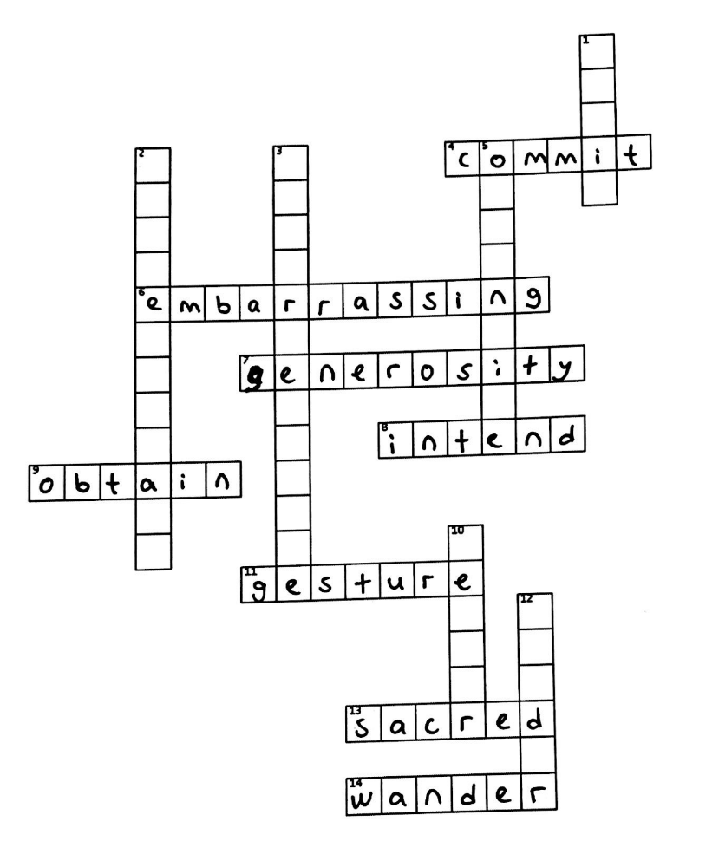
STUDENT A: Please explain the words “ACROSS”. Then, listen to student B to guess the words “DOWN”.

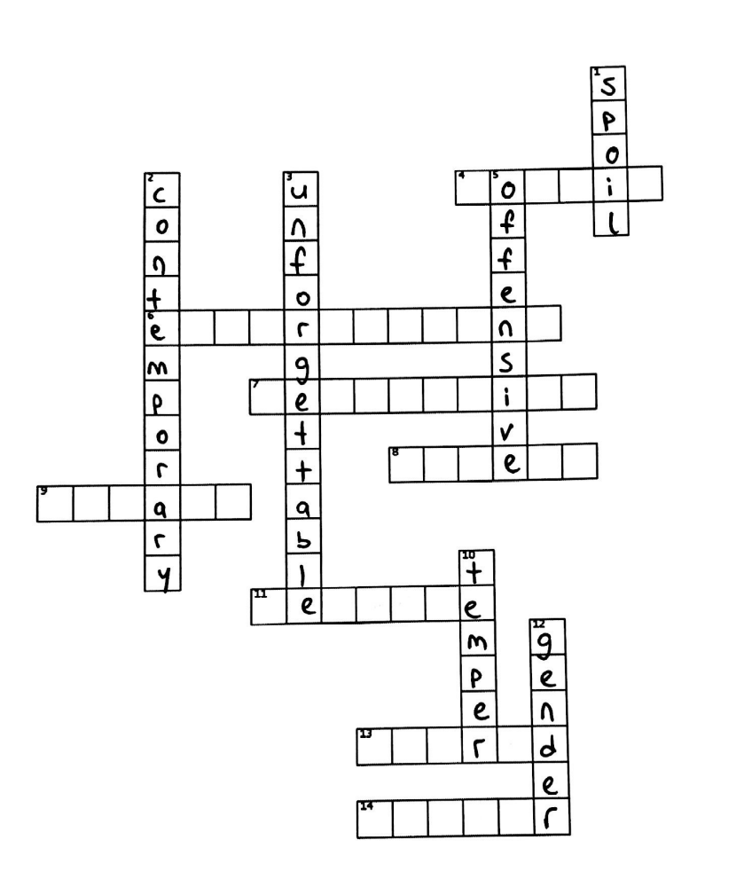
STUDENT B: Please explain the words “DOWN”. Then, listen to student A to guess the words “ACROSS”.

PART 5
Take turns with your pair and ask the following questions to each other. Please make sure that you use the words in bold in your answer.
- What kinds of situations embarrass you?
- What factors might push people to commit a crime?
- What do you intend to do after graduation?
- Who has shown you the most generosity in your life, and how did it impact you?
- What contemporary authors do you enjoy reading the most, and why?
- Which resources should people use to obtain information about the world events?
- Do you make gestures while speaking? How does it affect the conversation?
- Do you like wandering around the city? How does it make you feel?
- Can you talk about your unforgettable holiday?
- What do you do when you lose your temper?
- What kinds of gender differences do you observe in your social life?
- What do you find most offensive in social media interactions, and how do you typically respond?

“Please write a wh question with the given words. Use the strong collocation of the given word. Questions should help people to relate with content and personalize the given word. Use language at CEFR B2 level.”.ChatGPT. Revised and Worked on by SG. in June 2024. Proofread by CK, June, 2024.

ANSWER KEY
PART 1 | PART 2 | PART 3
- B  - C  - D  - D  - A | - E  - C  - B  - A  - B  - A  - D  - A  - E  - E  - B  - C  - A  - E | - STRATEGICALLY  - SIMPLIFICATION  - IMMIGRATION  - RELEVANT  - UNFORTUNATELY  - CLARIFICATION

